|  |  |  |  |  |  |  |  |  |
| --- | --- | --- | --- | --- | --- | --- | --- | --- |
| **TITLE OF ACTIVITIES/ PROGRAM** | **DATE/ DURATION** | **DOCUMENTATION (PICTURES)** | | | **PARTICIPANTS** | **LOCATION** | **CONDUCTED/ SPONSORED BY:** | **BUDGET/ REMARKS** |
| Validated student I.D.(s) | January –March 2021 | Refer to OSAS Log Book/Document | | | LSPU students | Office of Student Affairs and  Services | OSAS | --- |
| Posted and disseminated relevant announcements and information pertaining to student services on OSAS Official Facebook Page / Social Media | January –March 2021 |  | C:\Users\James Simmond\Downloads\176444703_788533161780053_8277867946465001858_n.jpg |  | LSPU students | Office of Student Affairs and Services Facebook Official Page | OSAS | --- |
| Conducted survey thru online platform pertaining to satisfaction on the services of the office | January –March 2021 |  | C:\Users\James Simmond\Downloads\173690704_164416782237150_5501121180258507309_n.jpg |  | OSAS ICTS  LSPU Students | Online Platform | OSAS | --- |

|  |  |  |  |  |  |  |
| --- | --- | --- | --- | --- | --- | --- |
| Assisted in receiving and attending to student concerns related to student services via phone calls, chat, video conferencing in relation to Student Concerns Desk | January - March 2021 |  | LSPU students | Online Platform | OSAS | --- |
| Oath Taking of newly designated Supreme Student Council President of LSPU-SC | February 3, 2021 |  | OSAS Chairperson | Office of Student Affairs and Services | OSAS | --- |

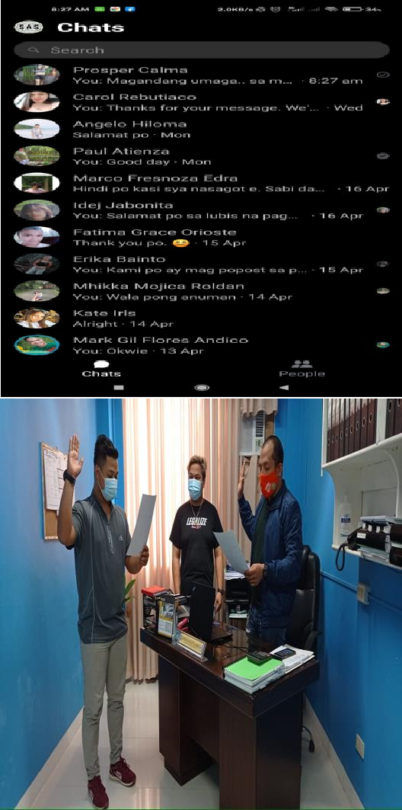

|  |  |  |  |  |  |  |
| --- | --- | --- | --- | --- | --- | --- |
| Distribution of certificates to the Awardees (Retirees and Special Awardees) during the celebration of LSPU Siniloan Founding Anniversary | February 10, 2021 |  | Retirees and Special Awardees | LSPU Siniloan Campus | OSAS | University Fund |
| Face-to- face meeting of OSAS Director and Chairpersons with Supreme Student Council Advisers, FSSC President and SSC Presidents of LSPU, reviewing the submitted proposal of FSSC Officers Constitution and By-laws | February 11, 2021 |  | OSAS Director & Chairperson Student Council Advisers Students Council Presidents Student Organization Coordinators | President’s Conference Room LSPU Sta Cruz Campus | Office of the Director, OSAS | Charge to OSAS |

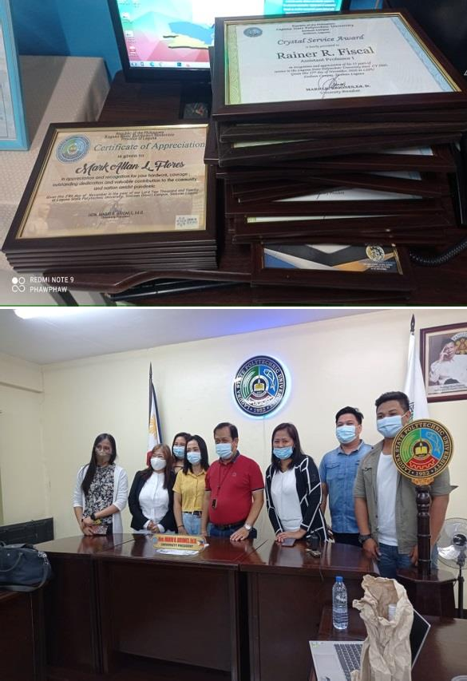

|  |  |  |  |  |  |  |
| --- | --- | --- | --- | --- | --- | --- |
| Attended webinar  entitled” LSPU Records and Digitalization of Records.” | February 18,2021 | C:\Users\James Simmond\Downloads\176244104_505801547460821_3082605100566061793_n.jpg | University Wide | Via ZOOM | University ICTS | --- |
| Signed Clearance(s) | March 2021 | Refer to OSAS Log Book/Document | LSPU students | Office of Student Affairs and  Services | OSAS | --- |
| Recommendation of Unit Heads Designation | March 3, 2021 | C:\Users\James Simmond\Desktop\DDDD.png | OSAS Director & Chairperson Faculty Members | Office of the Director, OSAS | Chairperson, OSAS | --- |

|  |  |  |  |  |  |  |
| --- | --- | --- | --- | --- | --- | --- |
| Coordinated with the concern’s personnel (ICTS, OSAS, PACD, QA  Chairperson and Security Services) for the plan and implementation of student online appointment to be presented to Campus Director | March 10, 2021 |  | ICTS, OSAS, PACD,  QA Chairperson and Security Services | CCS Building | University Clinic | --- |
| Attended the emergency meeting led by CD together with concerned personnel of LSPU to discuss the flow of transaction of visitors entering the school premises and set a plan for online transaction | March 10, 2021 |  | Frontline officers | LSPU-SC Board Room | Campus Director | --- |

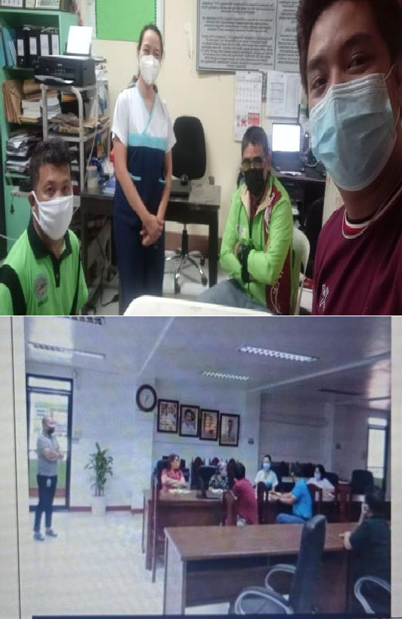

|  |  |  |  |  |  |  |
| --- | --- | --- | --- | --- | --- | --- |
| Coordinated with the RHU personnel for the strict implementation and observance of the COVID- 19 health protocol to control the number of visitors and students entering the campus | March 11, 2021 |  | Contact tracers, OSAS chairperson and QA Chairperson | OSAS | University Clinic | --- |
| Attended and participated in the virtual visit of CHED for the application of COPC to the College of Criminology Justice Education | March 11, 2021 |  | OSAS and other concerned units/offices | Via ZOOM | College of Criminology Justice Education | --- |

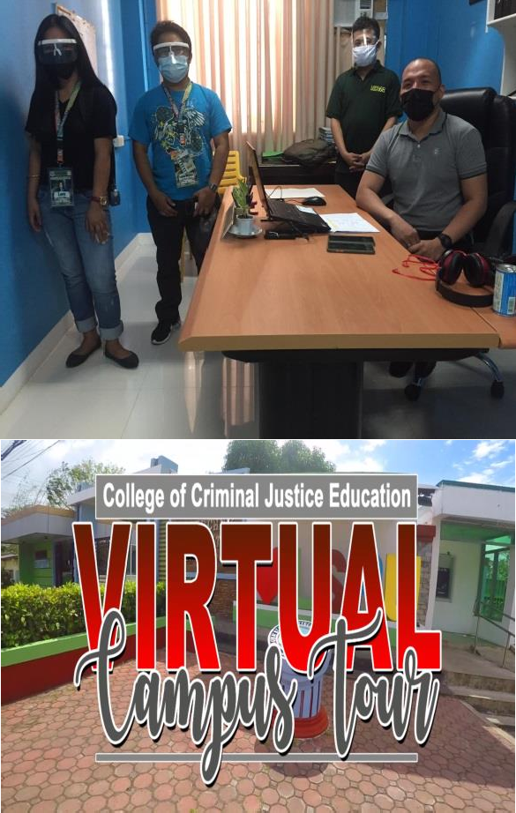

|  |  |  |  |  |  |  |
| --- | --- | --- | --- | --- | --- | --- |
| Attended and participated in the virtual visit of CHED for the application of COPC to the College of Arts and Sciences | March 19,2021 | C:\Users\James Simmond\Downloads\176403249_163581975660232_5530669262679403344_n (1).jpg | OSAS and other concerned units/offices | Via ZOOM | College of Arts and Sciences | --- |
| Validated student I.D.(s) | April-June 2021 | Refer to OSAS Log Book/Document | LSPU students | Office of Student Affairs and Services | OSAS |  |
| Posted and disseminated relevant announcements and information pertaining to student services on OSAS Official Facebook Page / Social Media | April-June 2021 |  | LSPU students | Office of Student Affairs and Services Facebook Official Page | OSAS |  |

|  |  |  |  |  |  |  |
| --- | --- | --- | --- | --- | --- | --- |
| Conducted survey thru online platform pertaining to satisfaction on the services of the office | April-June 2021 |  | OSAS ICTS  LSPU Students | Online Platform | OSAS |  |
| Assisted in receiving and attending to student concerns related to student services via phone calls, chat, video conferencing in relation to Student Concerns Desk | April-June 2021 |  | LSPU students | Online Platform | OSAS |  |

|  |  |  |  |  |  |  |
| --- | --- | --- | --- | --- | --- | --- |
| Distribution of Prizes to the 7 students lucky winners of Pocket Wifi(s) from Smart Telecommunication | April 19-23, 2021 |  | LSPU students |  | OSAS | Smart Telecomm unication |
| Distribution of Prizes to the part-timers (faculty) lucky winners of Pocket Wifi(s) from Smart Telecommunication | May 17-21, 2021 |  | Part Timers |  | OSAS | Smart Telecomm unication |

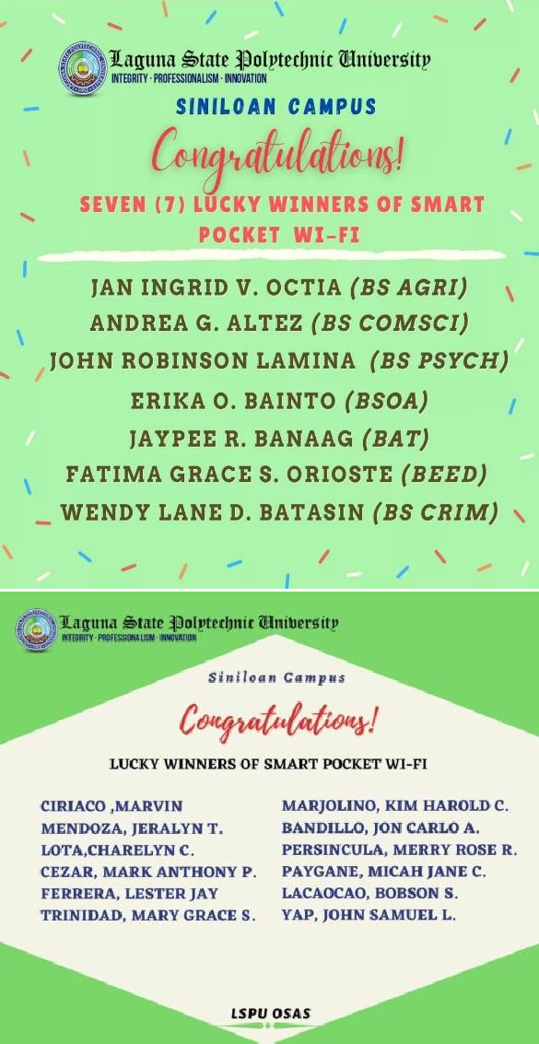

|  |  |  |  |  |  |  |
| --- | --- | --- | --- | --- | --- | --- |
| Validated student I.D.(s) | October - December 2021 | Refer to OSAS Log Book/Document | LSPU students | Office of Student Affairs and Services | OSAS |  |
| Posted and disseminated relevant announcements and information pertaining to student services on OSAS OfficialFacebook Page / Social  Media | October - December 2021 |  | LSPU students | Office of Student Affairs and Services Facebook Official Page | OSAS |  |
| Conducted survey thru online platform pertaining to student vaccine status | October - December 2021 |  | LSPU Students | Online Platform | OSAS |  |

|  |  |  |  |  |  |  |
| --- | --- | --- | --- | --- | --- | --- |
| Renewal of Standard Insurance Inc. as our insurance provider for LSPU Siniloan Campus for the SY- 2021-2022 | October - December 2021 |  | LSPU  Community | LSPU Siniloan Campus | OSAS | ₱207,120.00 |
| LSPU 69TH Founding Anniversary Virtual Meeting | October - December 2021 |  | Concerned Offices | Via Zoom | OSAS  *(In Charge)* |  |
| Conducted Covid 19 vaccination Information drive/dissemination as part of our Back to LSPU ,Back to Bakuna Program | October - December 2021 |  | LSPU  Community | Online Platform | OSAS | ₱78,500.00 |

|  |  |  |  |  |  |  |
| --- | --- | --- | --- | --- | --- | --- |
| Prepared, laid out and disseminated invitation program for LSPU 69TH Founding Anniversary | October - December 2021 |  | LSPU-SC  Community | Online Platform | OSAS  *(In Charge)* |  |
| LSPU-SC Virtual Celebration of 69th Founding Anniversary | October - December 2021 | *For more evidence of the event please browse the OSAS FB Page: Office of the Student Affairs and Services Siniloan Campus* | LSPU-SC  Community | Via Live Streaming (Facebook) | OSAS  *(In Charge)* | ₱274,300.00 |
| Conduct of Online Consultative Meeting with the students pertaining to Mental Health Policy | November 2021 |  | OSAS Unit Heads, Students | Zoom | OVPAA and OSAS |  |

|  |  |  |  |  |  |  |
| --- | --- | --- | --- | --- | --- | --- |
| Mental Health Policy Process  / Procedure Development Virtual Meeting | October - December 2021 |  | Concerned Offices | Via Zoom | OSAS  *(In Charge)* |  |
| Assisted in receiving and attending to student concerns related to student services via phone calls, chat, video conferencing in relation to Student Concerns Desk | October - December2021 |  | LSPU students | Online Platform | OSAS |  |
| **SUPPORT FUNCTIONS** |  |  |  |  |  |  |
| Attendance to University wide Academic and Administrative  Council Meeting | January to December 2021 |  | LSPU Officials | Zoom | LSPU |  |
| Issuance of Office  Memorandums | January to  December 2021 |  | LSPU Officials | Online Platform | OSAS |  |
| Conduct of OSAS Regular  meeting | September to  December |  | OSAS Unit Heads | Google Meet | OSAS |  |

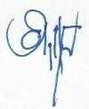Prepared by:

**JAYSON N. OLAYTA, MRD**

OSAS Chairperson

Noted:

**ENGR. JOSEPH M. CABIENTE, MBM, MSME**

LSPU Siniloan Campus Director

Submitted to:

**ZERAH-JANE M. MORTEL**

MIS, Chairperson